**7 Dec 2018** **The Weekly Bulletin of Rotary Club of Kathmandu Mid-Town** **bc-12.12/018**

|  |
| --- |
| C:\Users\Public\Documents\RIP T1819_EN.png |

District: 3292 Web:www.rotarymidtown.org.np Club Id: 26776

**DECEMBER IS DISEASE PREVENTION AND TREATMENT** **MONTH**

Disease prevention and treatment takes on many forms, from supporting studies to helping immunize people to improving drinking water and the sanitation infrastructure. The world relies on Rotary to tackle these global challenges, and to set an example for others to follow.

Rotary Clubs can:

- Support health education program that explain how diseases are spread and promote ways to reduce the risk of transmission.

- Carry out immunizations against infectious diseases.

- Improve the capacity of local health care professionals.

- Enhance the health infrastructure of local communities.

- Sponsor continuing education and training for health workers, including supporting scholarships, stipends and public recognition.

- Improve and expand access to low-cost and free health care in under-served areas.

**Club Meeting # 1466** : 30 Nov 018

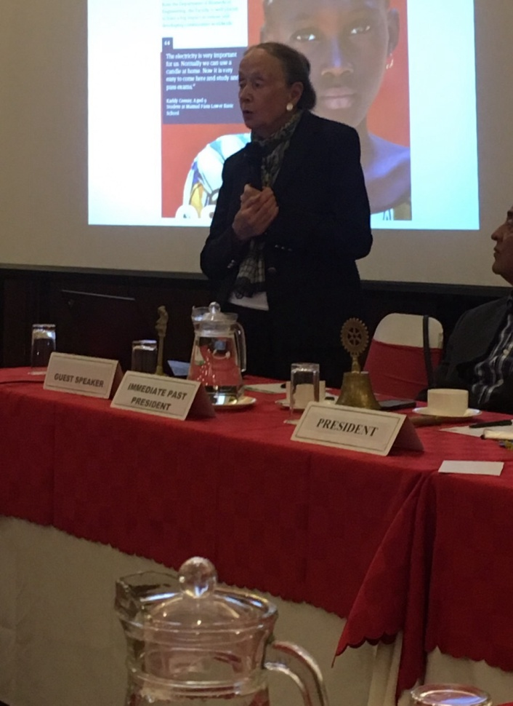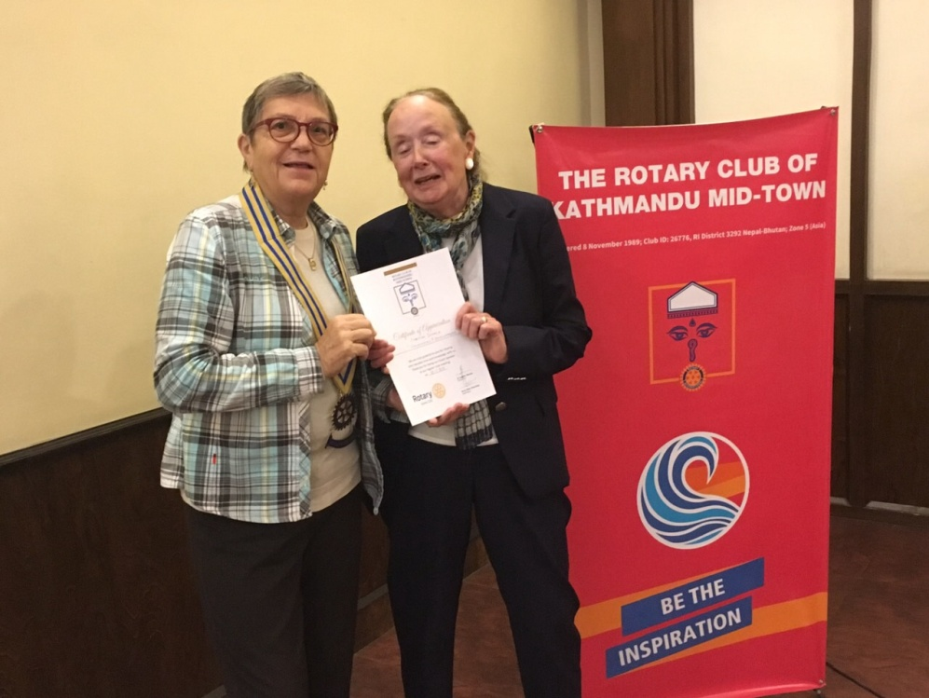 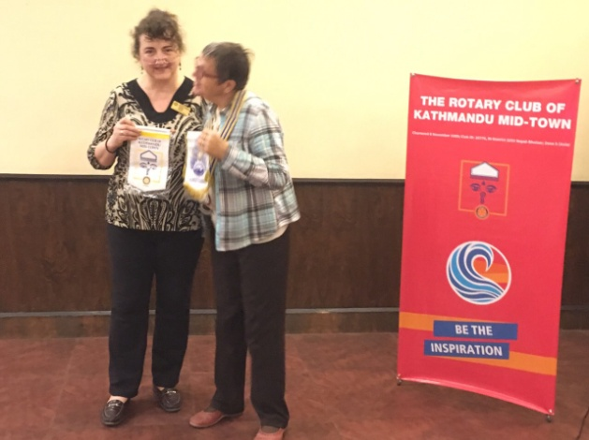

Guest speaker Ms. Christine Donald President Jo handing over a Exchanging club banners

presenting her talk. certificate of appreciation .

*Photo courtesy: Rtn Shyam R Thapalia*.

# Weekly Meeting/Program Schedule:

|  |  |  |
| --- | --- | --- |
| Date | Program/ Speaker | Topic of Presentation |
| 7 Dec 2018 | Club Assembly |  |
| 12 Dec 2018 | DG Visit |  |
| 7.15 - 8.30 am | DG’s special meeting with the President, P Elect & Secretary, Rotaract and Interact Presidents |  |
| 8.30 - 9.30 am | Regular Meeting |  |

Friday Meeting: 7 Dec

Club Assembly. No guest allowed

**District Governor Visit**

The purpose of the District Governor’s visit:

Briefing clubs in important Rotary issues and promoting the goals of the RI President.

Providing support and attention to weak or struggling clubs.

Motivating Rotarians to participate in service activities to strengthen the programs of Rotary.

Listening to clubs goals, its communities and communicating with Club members.

Recognizing the contributions of Rotarians in the Club

*Source: Rotary.org*

**Give the Gift of Rotary:**

Why give the gift of Rotary? Because your gift can make a difference in this world by helping others in need. The Rotary Foundation supports the hard work of Rotarians around the world proving sustainable solutions to their communities’ most pressing needs. But we still have work to do.

With your help, we can make lives better in your community and around the world. Please give the gift of Rotary today and together we can keep ***Doing Good*** in the World.

*Source: Rotary.org*

**ROTARY RECOGNIZES UK PRIME MINISTER THERESA MAY**

Rotary honored Theresa May, prime minister of the United Kingdom, with the Polio Eradication Champion Award for her leadership and political support toward ending polio.

Rotary International President Barry Rassin presented the prestigious award at a roundtable discussion on polio eradication on 27 November in London, England.

Under May’s leadership in 2017, the UK pledged about $130 million to the GPEI for 2017-19, bringing the country’s cumulative support for polio eradication to $1.6 billion, second only to the United States. “May has also been a strong advocate for other countries in the G-20 and G-7 to maintain their financial and political support for a polio-free world”, Rassin said.

Rotary established the Polio Eradication Champion Award in 1996 to recognize heads of state, health agency leaders, and others who have made significant contributions to ending polio. Past recipients include [Canadian Prime Minister Justin Trudeau](https://www.rotary.org/en/justin-trudeau-accepts-polio-eradication-champion-award), Japanese Prime Minister Shinzo Abe, German Chancellor Angela Merkel, Nigerian President Muhammadu Buhari, and former UN Secretary-General Ban Ki-moon.

*Source: Rotary.org*

**Rotary International Convention, Hamburg:**

REGISTRATION FEES: ONLINE, MAIL, FAX

**Important deadlines:**

**15 December 2018:** Last day for early-registration discount

**31 March 2019:** Last day for preregistration discount

**5 June 2019:** Last day for online registration

28 June - 15 Dec 2018 16 Dec 2018 - 31 Mar 2019 1 Apr - 5 Jun 2019

Rotarian US$ 395 US$ 495 US$ 595

Rotaractor US$ 120 US$ 170 US$ 220

Interactor US$ 20 US$ 30 US$ 40

*Source: Rotary.org*

**District Programs:**

**Rota Quiz** on 10 Dec 2018 (Monday) 8-10 AMat Hotel Gauri Shankar, Dhulikhel

**Rotary Foundation Seminar on** 22 Dec 2018 (Saturday) at Hotel yak & Yeti

**Committee Chairs’ Column:** *(This column is for use by chairpersons of 5 permanent committees: Club Administration, Membership, Public Relations, Service Projects, and the Rotary Foundation)*

**Members’ Corner:** *(This column is for Club members to express anything they would like in matter of Club activities, Club administration, Club issues or on Breakfast Chatter, or on anything else that would be of interest to fellow members.)*

**A THOUGHT FOR TODAY:**

**Progress is impossible without change, and those who cannot change their minds cannot change anything. -** [George Bernard Shaw](http://homeinsteaders.org/authors/george-bernard-shaw-quotes/)

On Lighter Side:

Two blondes were sitting in a pub watching the Tour de France on TV.

Barbara shakes her head and asks, "Why on earth do they do that?"

"Do what?" asks Eddie.

"Go on bikes for miles and miles, up and down hills, round the bends, day after day, week after week. No matter if it's icy, rainin', snowin', hailin' ......why would they torture themselves like that?"

"It's all for the prestige and the money," says Eddie. "You know the winner gets about half a million Euros!"

"Yeah, I understand that," says Barbara, "but why do all the others do it?

The responsibility we’ve been given is to build on the work of those who have gone before us — and

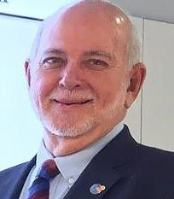

build a solid foundation for the work yet to come — by serving as effectively and as efficiently as we

can; keeping our work transparent and accountable; changing the lives of as many people as

possible for the better, in the most significant and lasting ways; and ensuring that Rotary continues

to provide the best possible experience to its members. That it continues to grow and be useful to

the world, not just this year and the next, but beyond our own time in Rotary, and even beyond our

own time on earth.

**RI President Barry Rassin**

Please send information on club activities, progress reviews on service projects, relevant photos etc to:

BC Editor: RR Shrestha email: rryesrr@gmail.com

## 7 Dec 2018 The Weekly Bulletin of Rotary Club of Kathmandu Mid-Town bc-12.12/018